**INHA UNIVERSITY TASHKENT**

**DEPARTMENT OF CSE & ICE**

**SPRING SEMESTER 2021**

**SOC 2110 - INTERNET PROGRAMMING**

Project work

Company Name:

***Humosoft***

Submitted by

Student Name Student ID

Mirzaakbarov Javokhirbek U1910279

Gulomov Shokhrukhmirzo U1910272

Mavlonov Shakhzod U1910277

Khalimetov Mukhiddin U1910274

Urmonov Azizbek U1910288

Yangiboev Komiljon U1910221

Github URL: <https://github.com/iuthub/group-project-humosoft-ip>

Website URL: http://45.156.24.250:7777



`

**ABSTRACTS**

This Online Shopping is a web-based application intended for online retailers. The main objective of this application is to make it interactive and easy to use. It would make searching, viewing, and selecting a product easier. It contains a sophisticated search engine for the user's to search for products specific to their needs. The search engine provides an easy and convenient way to search for products where a user can search for a product interactively and the search engine would refine the products available based on the user’s input. The user can then view the complete specification of each product. They can also view the product reviews and also write their reviews.

**HUMOSOFT**

Shopping has long been considered a recreational activity by many. Shopping online is no exception. The goal of this application is to develop a web-based interface for online retailers. The system would be easy to use and hence make the shopping experience pleasant for the users. The main purpose of this company is to provide a smooth and easy service to the customer with many conveniences as possible. Through online shopping, Customers will have a variety of choices to decide what to buy based on likes and product popularity. There are lots of convenience for customers when they visit the website. They can search for the particular product that they like, then they can add it to the card. On the one hand, Admin will see how many requests have been made and respond to that through the contact they have left. Overall, Humosoft is one of the modern web-based applications that are user-friendly, good-looking, smooth application.

**IMPLEMENTATION**

Here is the Home Page of our website

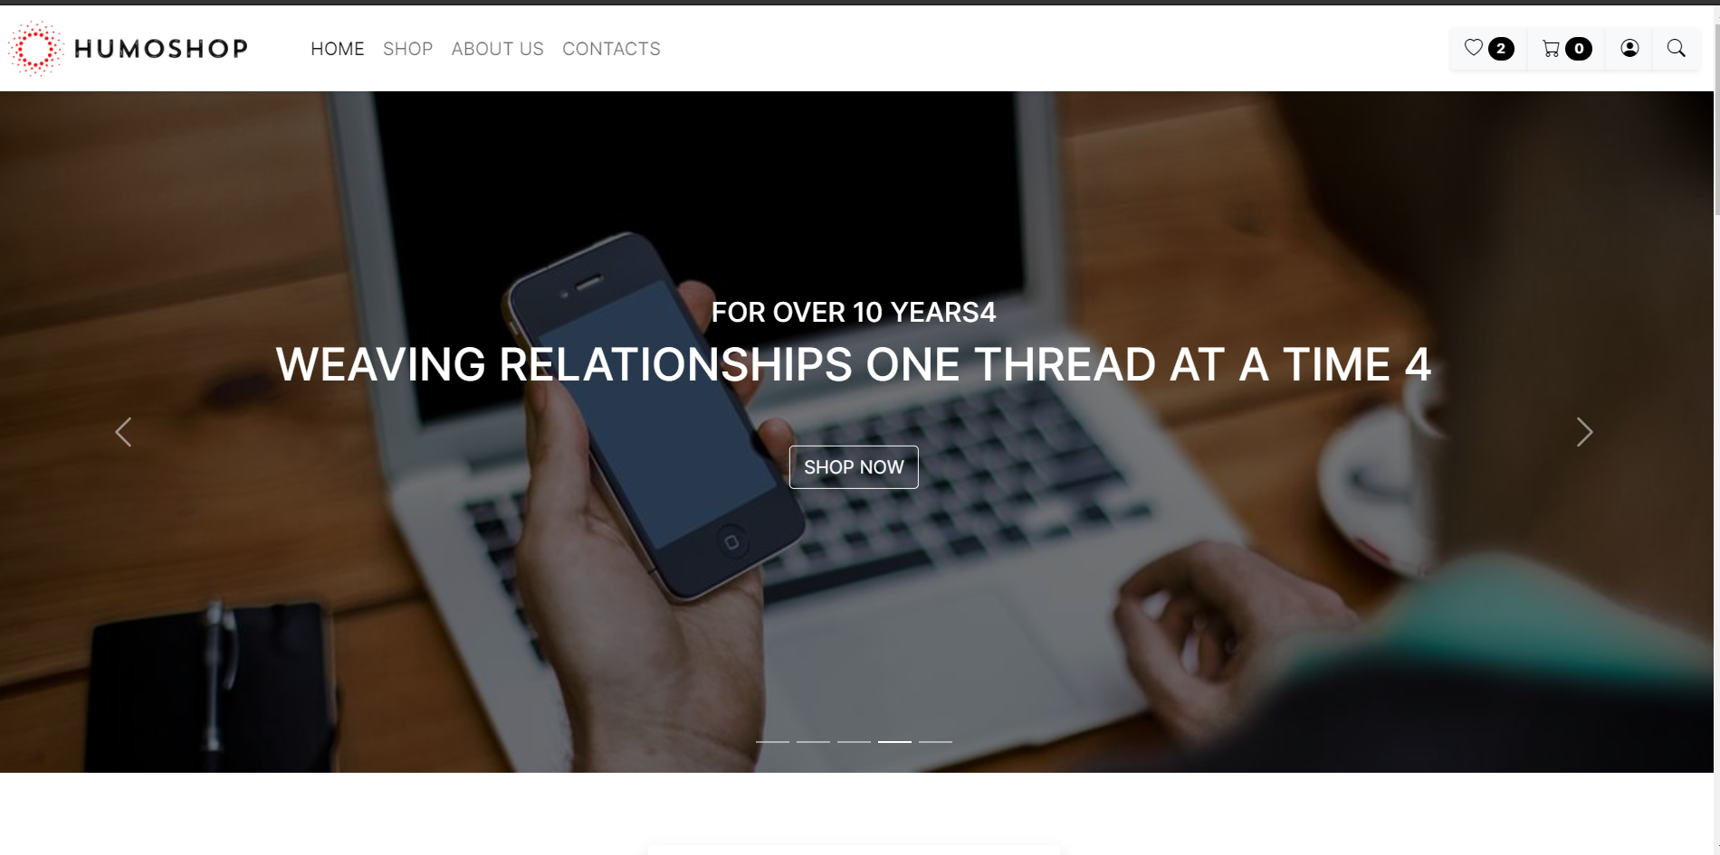

Let’s talk about the Navbar header. As you can see, 4 categories solely demonstrate a single page. On the top right, likes indicator, carts, and login also, the search button is located. They have particular functionality that we talk about later.

When you scroll down, you see featured products that are categorized according to their type.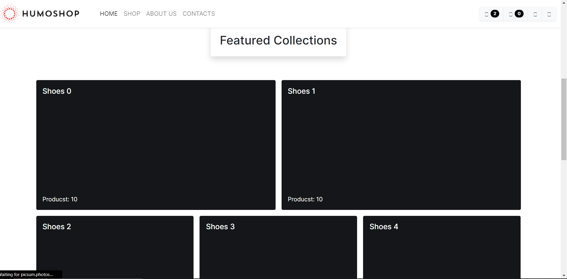

***Contribution of each member***.

Regarding the contribution of our groupmates, we subdivide the work of the project into several parts. Hence, we can keep track of what is going on in the overall scene. Shakhzod and Javokhirbek were responsible for the early design and functionality of the website. In particular, Shakhzod steps up in the process of front-end modifications and creations. Client-side parts were easy at the beginning, as we went along with Javascript, we tried to make it more feel and look so that when the user visits, he or she sees the good feeling of design. Javokhirbek made a huge contribution to the overall setups and the connection of the back-end and front end, database. On the other hand, Mukhiddin and Shohrukhmirzo were responsible for sever side. Most of the Back end part, authorization, login, user account adding was implemented by Mukhiddin. Azizbek and Komiljon were in the charge of database connectivity. By the usage of MySQL database, we implemented tables that can contain data of users when they visit and leave comments.

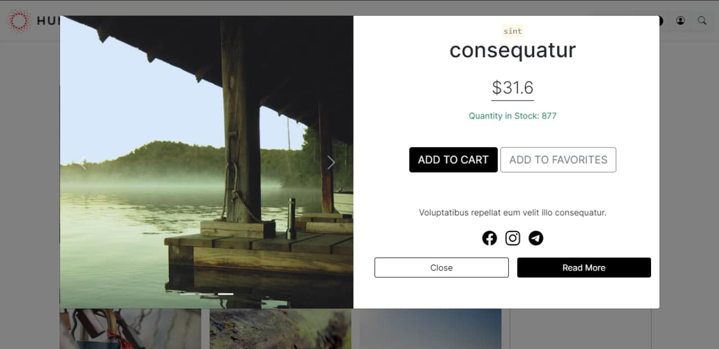

This modal page quickly describes brief information about the product that the user has recently clicked on. The modal window includes carousel with images of the product and the name and price, also couple of buttons for important functionalities.

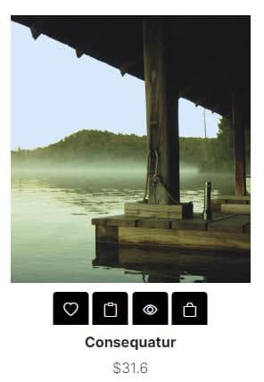The window aside shows card view for single product with image of the product. 4 icons below the product image has 4 functionalities:

Like/dislike, copy link, quick review, add to cart features respectively.

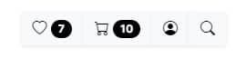This shows liked products, cart with chosen products, and account as well as search feature.

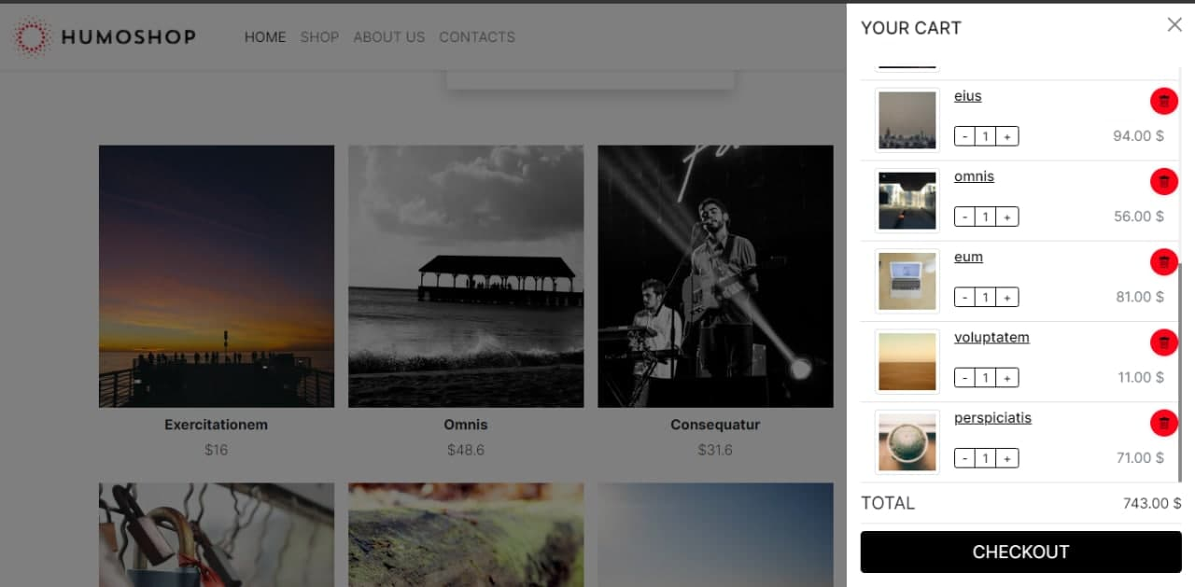

By clicking cart icon located in navigation bar, user is able to see the chosen products for cart, the view also includes brief information like price, name and also red button for removing item from the cart. Checkout feature checks out the buying process.

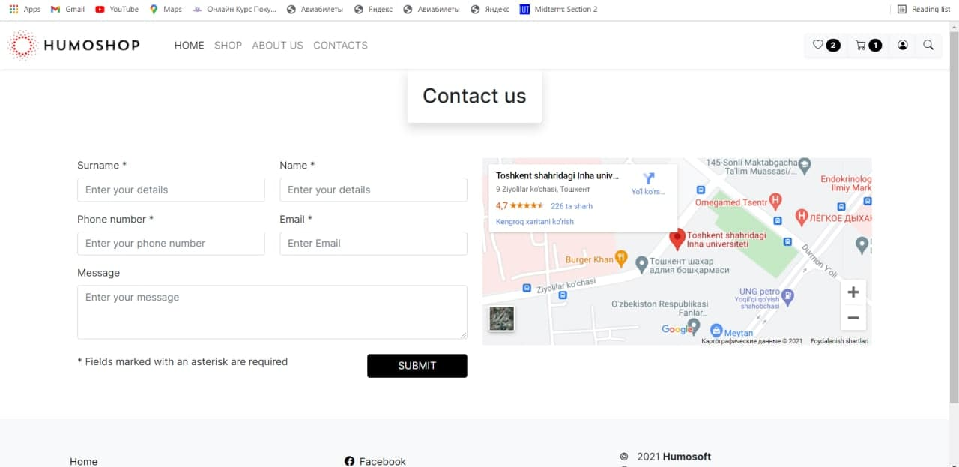

The contact page includes form for submitting reviews and complaints about the company. Also, user can find location of the company with the help of embedded map provided to the next of form.

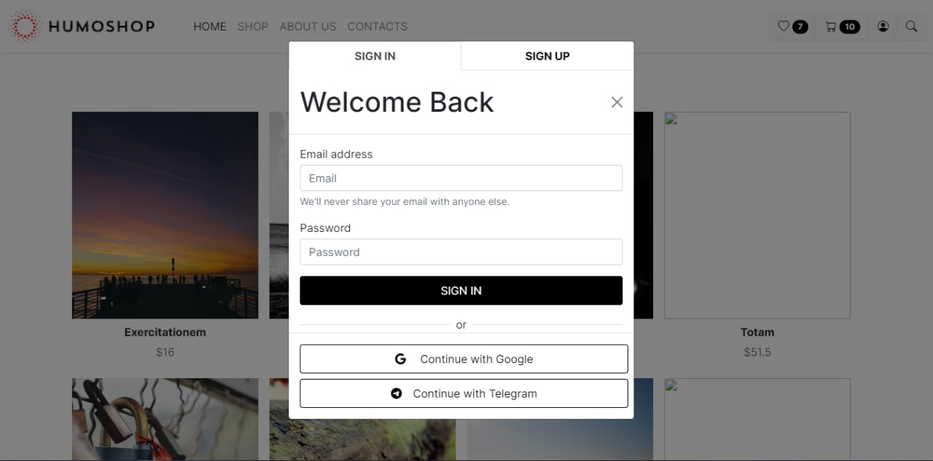

Users can either login using their email and password, or sign up if they have not registered yet. Each data is stored in the database. Also, it is possible to login with Google and Telegram accounts using their API.

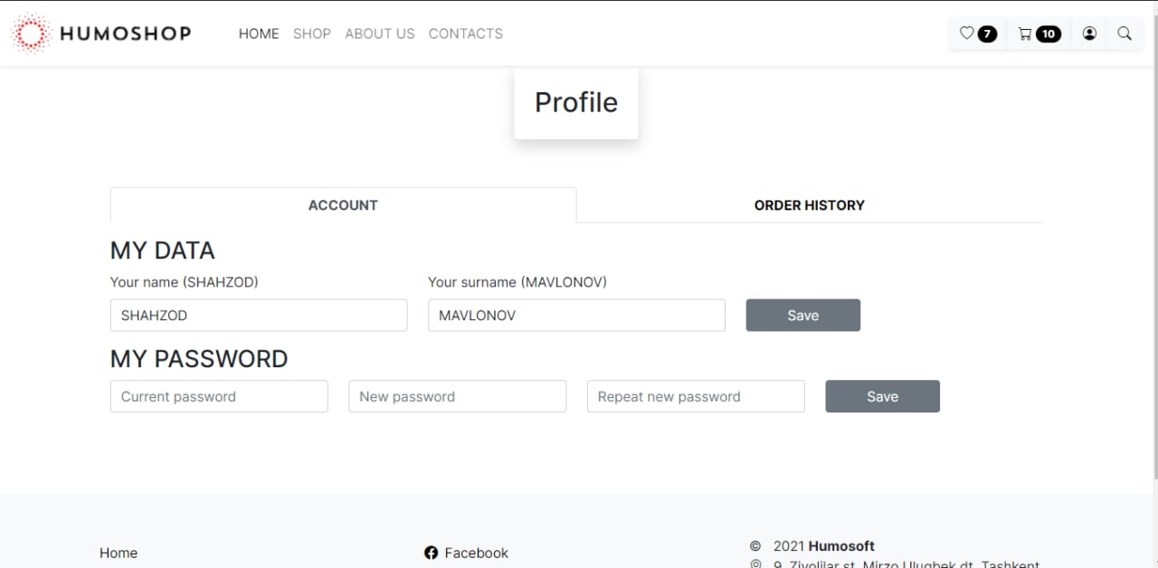

In the profile section, we made it as simple as possible so that users do not confuse when entering their data. They have only name and password to update, which is enough for our website.

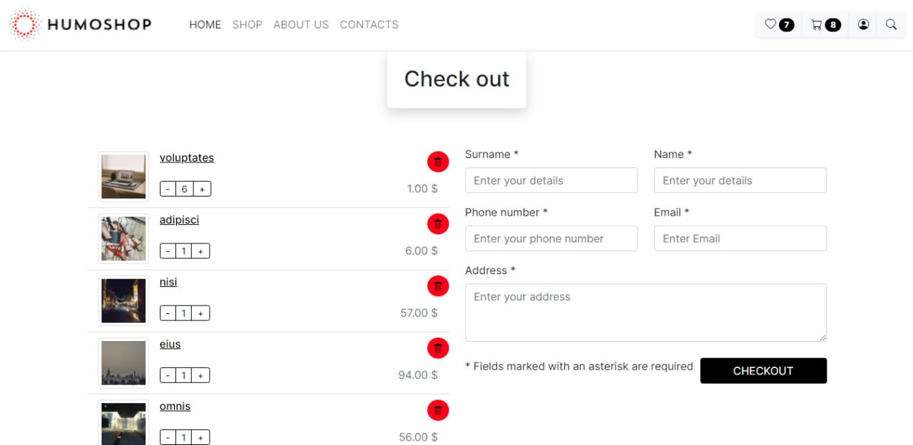

The checkout section is used to clarify users’ details in order for us to reach them precisely and make sure they inputted correctly. Users can also add, modify, substitute and delete items.

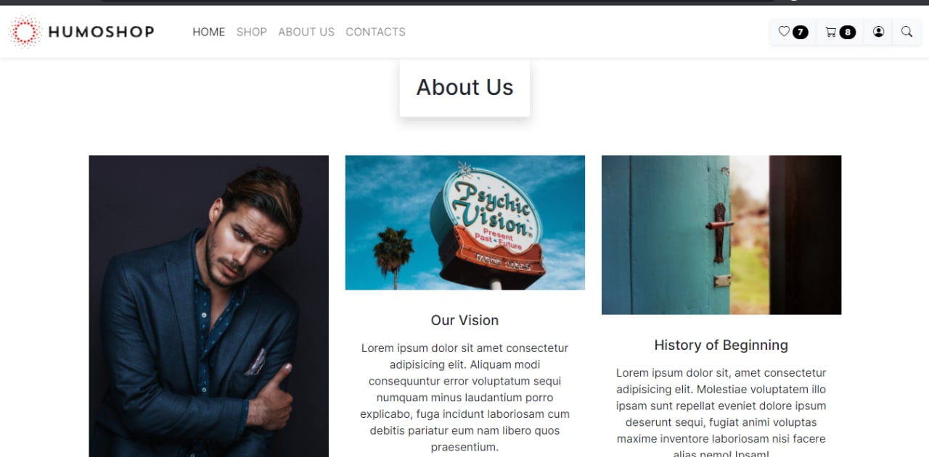

About page provides information about website items and developers behind the project. The page also includes info about company’s vision, history and main aim of the company.